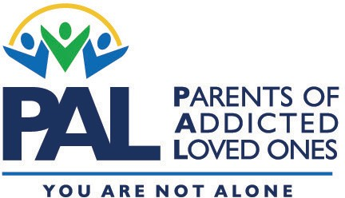
FREE PARENT SUPPORT GROUP

For families of adult children
dealing with substance addiction
Participants must be 18 or older

Parents of Addicted Loved Ones (PAL)
PROVIDES HOPE
through education and support

“PAL
brought back hope, sanity and
purpose in our lives.
We have learned to live again.”
- PAL parent

DATE AND TIME
LOCATION NAME
Address
CONTACT: Facilitator name
Email and/or phone number

FREE weekly meetings feature:
- Education
- Peer-to-peer support

FIND OUT MORE ABOUT PAL:
www.palgroup.org
TOPICS INCLUDE:
The addiction cycle • Enabling behaviors • Delayed emotional growth Role of the family • Setting realistic boundaries • Emotional detachment Financial strings • Steps of recovery • Recognizing relapse

